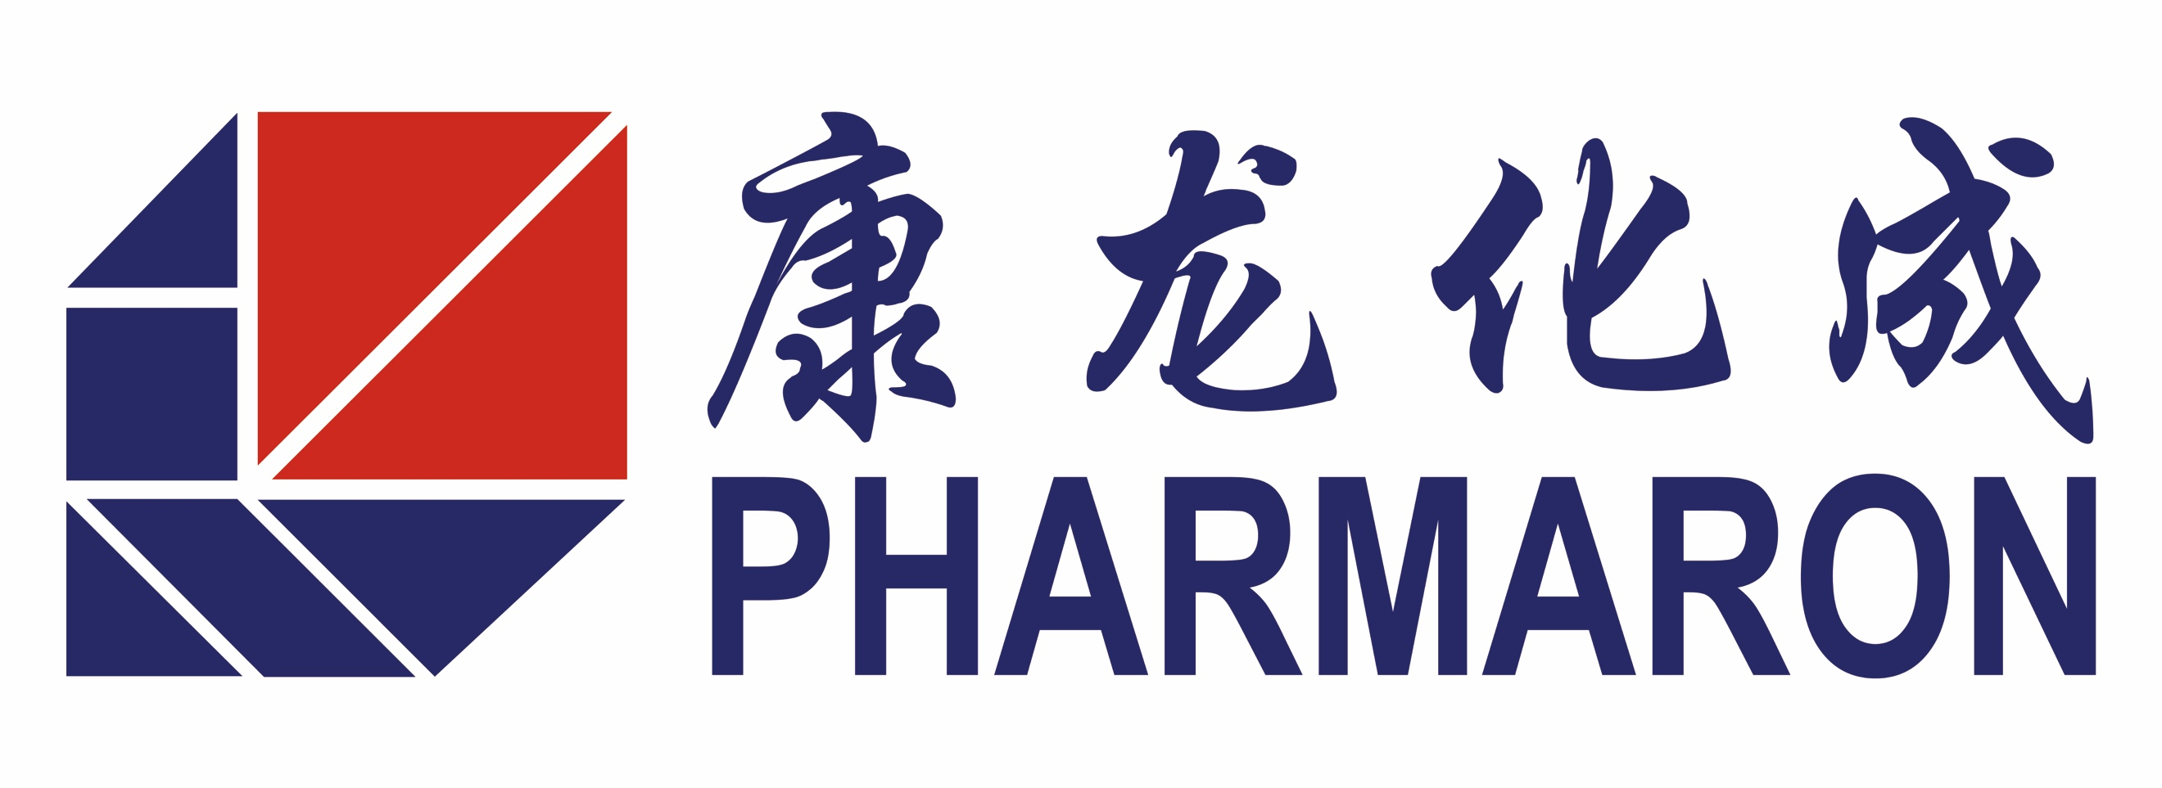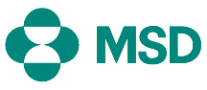
For Immediate Release
Pharmaron and MSD agree deal to acquire MSD’s UK Hoddesdon site
MSD to continue to remain on site and lease the main office buildings as part of a shared site agreement
Beijing, September 26, 2016 Pharmaron has entered into a non-binding Heads of Terms (HoTs) with Merck Sharpe & Dohme Limited (MSD) for the sale of the Hoddesdon UK site which includes MSD’s process development and research facility. The parties hope to complete the deal in Q1 2017.
Pharmaron sees this as a unique opportunity to acquire state-of-the-art Good Manufacturing Practice (GMP) standard facilities for the development of Active Pharmaceutical Ingredients (API) and formulation development in Europe to complement Pharmaron’s existing world class chemistry and integrated drug discovery and development services globally. Under the deal, MSD will remain on site on and lease-back the main office buildings.
Louise Houson, Managing Director, MSD UK and Ireland commented: “We are very pleased to be progressing this deal with Pharmaron. This deal will secure the future of the site while meeting the changing business needs of MSD and its employees for the foreseeable future. It also ensures MSD’s scientific legacy in Hoddesdon continues, with the potential to create local opportunities for our scientific staff in their areas of expertise.”
Boliang Lou, Chairman and CEO of Pharmaron commented that: “This is an exciting opportunity to have an industry-leading R&D site join the Pharmaron group, which once again demonstrates our commitment to our mission to become a world leader in small molecule drug R&D services. It allows us to develop our global capabilities in process chemistry and manufacturing services area, strengthening our capabilities in fully integrated R&D services. Together with the recent addition of GMP radiochemistry and GCP/GLP metabolism platforms through acquisition of Quotient Bioresearch in the U.K., this deal further consolidates our strategic position in Europe to better serve our partners globally, particularly in Europe.”
Commercial details on the transaction are not being disclosed.
###
About Pharmaron
Pharmaron is a private, premier R&D service provider for the life science industry. Founded in 2003, Pharmaron has invested in its people and facilities, and established a broad spectrum of drug R&D service capabilities, ranging from synthetic and medicinal chemistry, biology, DMPK, pharmacology, safety assessment, radiochemistry and radiolabelled metabolism to chemical & pharmaceutical development. With about 4,000 employees and operations in China, the U.S. and the U.K., Pharmaron has an excellent track record in the delivery of R&D solutions to its partners in North America, Europe, Japan and China. For more information, please visit: www.pharmaron.com

About MSD
For 125 years, MSD has been a global healthcare leader working to help the world be well. MSD is a trade name of Merck & Co., Inc., Kenilworth, NJ., USA. Through our prescription medicines, biologic therapies, and animal health products, we work with customers and operate in more than 140 countries to deliver innovative health solutions. We also demonstrate our commitment to increasing access to healthcare through far-reaching policies, programmes and partnerships. For more information, visit www.msd-uk.com.

For more information, please contact:
Pharmaron: Ashok Tehim, Sr. VP, Strategy, Tel: +1 201 312 5754, ashok.tehim@pharmaron.com
Ellen Cabral, Director, Global Marketing, Tel: +1 617 901 2216, ellen.cabral@pharmaron.com

MSD: Meral Nugent, Tel: 01992 452358, Mob: 07884 232042, meral.nugent@merck.com

